AI-Powered Plant Disease Detection and Treatment
Recommendation using Deep Learning and Hugging
Face Generative AI
Plant diseases are a major threat to global agriculture, often causing severe losses in crop yield and quality. Many farmers struggle to identify diseases early, especially when symptoms are subtle or resemble nutrient deficiencies. Limited access to experts and timely diagnosis further complicates effective disease management.
This project aims to build an AI-driven system that can detect plant diseases directly from leaf images. It will classify the specific disease type using a trained deep-learning model. Then a Hugging Face Large Language Model will generate treatment recommendations. Therefore, this solution empowers farmers with quick, accurate, and actionable guidance for healthier crops.
For training a Deep learning model to achieve plant disease detection, required dataset is taken from kaggle which has following specifications:
- Source: Kaggle – https://www.kaggle.com/datasets/vipoooool/new-plant-diseases-dataset
- Total Classes: 38 Plant Disease Categories
- Supported Crops:
- Apple
- Corn
- Tomato
- Potato
- Grape
- Peach
- Pepper
- Strawberry
- Cherry
- Orange
- Healthy and Diseased Samples: Each crop contains Healthy Images and Diseased Images. This enables both disease detection and healthy plant identification.
Approach:
- Data Pre-processing
- Model Development
- Baseline CNN Model
- Pre-trained model
- Evaluation
- Hugging Face Generative AI Integration
- Deployment Layer

Phase 1: Data Pre-processing
The dataset taken from kaggle is already augmented with 256×256 resizing, horizontal flip and Brightness Adjustment. It is divided into train, validation and test folders.
But a slight adjustment is made in resizing, by considering 224×224 resizing. Then pixel normalization is done.

Phase 2: Model Development
Baseline CNN Model:
Firstly a baseline CNN model was built and trained on massive dataset. This is just to check whether the advanced model/pre-trained model is doing better than this or not. The approach of the model is explained in the following steps:
- Defining dataset path
base_dir = '/content/dataset'

train_dir = os.path.join(base_dir, 'New Plant Diseases Dataset(Augmented)/train')
valid_dir = os.path.join(base_dir, 'New Plant Diseases Dataset(Augmented)/valid')
test_dir = os.path.join(base_dir, 'New Plant Diseases Dataset(Augmented)/test')

- Data Transforms and Loaders
transform = transforms.Compose([transforms.Resize((224, 224)), transforms.ToTensor()])

train_dataset = datasets.ImageFolder(root=train_dir, transform=transform)
valid_dataset = datasets.ImageFolder(root=valid_dir, transform=transform)

BATCH_SIZE = 64
train_loader = DataLoader(train_dataset, batch_size=BATCH_SIZE, shuffle=True, num_workers=4)
valid_loader = DataLoader(valid_dataset, batch_size=BATCH_SIZE, shuffle=False, num_workers=4)

This code creates a data pipeline that resizes images to 224×224 pixels and automatically scales their raw pixel values between 0.0 and 1.0 using ToTensor(). It then reads the organized plant disease folders, maps them to their respective categorical text labels, and groups the images into optimized batches of 64 using parallel worker threads to feed to the neural network quickly.
We are doing this to standardize our raw image files so they can be processed efficiently by a deep learning model. Resizing ensures all input dimensions match perfectly, scaling stabilizes numerical training to prevent vanishing gradients, and batching allows the GPU to process multiple leaf images simultaneously rather than waiting for slow individual files to load from the hard drive.
- Baseline CNN model Architecture
Standard CNN architecture includes:
- Conv2D
- MaxPooling
- Dropout
- Dense Layers
- Softmax Output
Similar architecture is implemented in this project using torch.

class BaselineCNN(nn.Module):
def __init__(self, num_classes = 38):
super(BaselineCNN, self).__init__()

self.features = nn.Sequential(
nn.Conv2d(3, 32, kernel_size=3, padding=1),
nn.ReLU(),
nn.MaxPool2d(2,2), # 112x112

nn.Conv2d(32, 64, kernel_size=3, padding=1),
nn.ReLU(),
nn.MaxPool2d(2,2), # 56x56

nn.Conv2d(64, 128, kernel_size=3, padding=1),
nn.ReLU(),
nn.MaxPool2d(2,2) # 28x28
)

self.classifier = nn.Sequential(
nn.Flatten(),
nn.Linear(128*28*28, 512),
nn.ReLU(),
nn.Dropout(0.5),
nn.Linear(512, num_classes)
)

def forward(self, x):
return self.classifier(self.features(x))

This is the custom convolutional neural network (CNN) that automatically classifies leaf images into one of 38 distinct plant disease categories. The network is split into two primary operational sequences: feature extraction (self.features) and classification decision-making (self.classifier). In the feature extraction sequence, three consecutive Convolutional layers (nn.Conv2d) apply mathematical filters to scan the images, systematically learning to identify structural traits like edges, vein arrangements, and disease spot shapes. Each convolution is immediately followed by a ReLU activation function, which injects non-linearity so the network can solve complex visual patterns. Max Pooling layers (nn.MaxPool2d) are then used to down-sample the image's spatial matrix dimensions step-by-step (halving them from 224 to 112, 56, and finally 28 pixels) to minimize processing overhead while retaining dominant visual features. In the classification sequence, the final multi-dimensional shape matrix is stretched into a single 1D vector of 100, 352 values using nn.Flatten. This flattened stream passes directly into a heavy Linear layer that compresses the parameters down to 512 hidden nodes to build intermediate categorical rules. To safeguard against overfitting, a Dropout layer randomly deactivates 50% of these nodes during training, preventing the model from memorizing specific training images. Finally, a concluding Linear output layer maps those 512 traits directly down to our 38 target class scores, while the forward function defines the direct computational pipeline that pipes our raw pixel tensors through the entire network to make a prediction.
- Training Loop
Then this model is trained in 10 epochs on GPU with a learning rate of 0.001. For each epoch train loss, train accuracy, validation loss and validation accuracy is calculated. Results at each epoch are:
Epoch | Train Loss | Train Accuracy | Val Loss | Val Accuracy
1 | 1.1171 | 66.60% | 0.4010 | 87.13%
2 | 0.4491 | 85.60% | 0.2321 | 92.47%
3 | 0.2891 | 90.68% | 0.2121 | 92.88%
4 | 0.2152 | 92.92% | 0.1764 | 94.47%
5 | 0.1700 | 94.39% | 0.1626 | 94.84%
6 | 0.1402 | 95.35% | 0.1662 | 94.63%
7 | 0.1224 | 95.97% | 0.1821 | 94.80%
8 | 0.1006 | 96.69% | 0.1608 | 95.30%
9 | 0.0888 | 97.11% | 0.1737 | 95.37%
10 | 0.0855 | 97.26% | 0.1846 | 94.86%

Pre-trained Model: A pre-trained ResNet18 model was taken and trained on massive dataset. The approach of the model is explained in the following steps:
- Defining dataset path
base_dir = '/content/dataset'

train_dir = os.path.join(base_dir, 'New Plant Diseases Dataset(Augmented)/train')
valid_dir = os.path.join(base_dir, 'New Plant Diseases Dataset(Augmented)/valid')
test_dir = os.path.join(base_dir, 'New Plant Diseases Dataset(Augmented)/test')

- Data Transforms and Loaders
resnet_transform = transforms.Compose([
transforms.Resize((224, 224)),
transforms.ToTensor(),
transforms.Normalize(mean=[0.485, 0.456, 0.406],
std=[0.229, 0.224, 0.225])
])

train_dataset = datasets.ImageFolder(root=train_dir, transform=resnet_transform)
valid_dataset = datasets.ImageFolder(root=valid_dir, transform=resnet_transform)

train_loader = DataLoader(train_dataset, batch_size=64, shuffle=True, num_workers=2, pin_memory=True)
valid_loader = DataLoader(valid_dataset, batch_size=64, shuffle=False, num_workers=2, pin_memory=True)

This is similar to the Baseline CNN model except the normalization. Here we used ImageNet Z-score normalization because ResNet model was pre-trained on the ImageNet dataset [0.485, 0.456, 0.406]. Pre-trained models do not look at raw pixels; instead, they expect the input data to have the exact same colour distribution, statistical mean, and standard deviation that they learned during their original training.
- Defining ResNet18:
# Loading Pre-trained ResNet18 weights
resnet_model = models.resnet18(weights=models.ResNet18_Weights.DEFAULT)

# Modifying the final layer (ResNet50's output layer is also called 'fc')
num_features = resnet_model.fc.in_features
resnet_model.fc = nn.Linear(num_features, 38) # Mapping to our 38 classes

- Training Loop
Then this model is trained in 10 epochs on GPU with a learning rate of 0.0001. For each epoch train loss, train accuracy, validation loss and validation accuracy is calculated. Results at each epoch are:
Epoch | Train Loss | Train Accuracy | Val Loss | Val Accuracy
1 | 0.1700 | 96.50% | 0.0448 | 98.74%
2 | 0.0172 | 99.59% | 0.0254 | 99.22%
3 | 0.0136 | 99.67% | 0.0175 | 99.53%
4 | 0.0110 | 99.72% | 0.0150 | 99.54%
5 | 0.0114 | 99.67% | 0.0168 | 99.45%
6 | 0.0082 | 99.78% | 0.0124 | 99.57%
7 | 0.0085 | 99.77% | 0.0183 | 99.45%
8 | 0.0054 | 99.86% | 0.0094 | 99.73%
9 | 0.0078 | 99.78% | 0.0147 | 99.55%
10 | 0.0060 | 99.82% | 0.0089 | 99.76%

Phase 3: Evaluation
We have seen loss and accuracy for both the models. Let’s see some additional evaluation metrics for both the models.
- Baseline CNN Model:
- Precision: 0.9501
- Recall: 0.9486
- F1 Score: 0.9484

- ResNet18 Model:
- Precision: 0.9976
- Recall: 0.9976
- F1 Score: 0.9976

So, by these evaluation metrics it is clear that both the models are performing well. But ResNet18 has more accuracy, precision, recall and F1 score compared to Baseline CNN model.
To check how each model is performing, few images were given to each model for prediction. The following are the predictions made by each model.
- Baseline CNN Model:
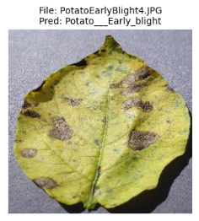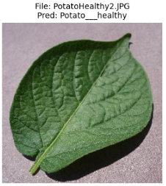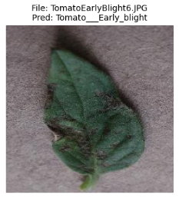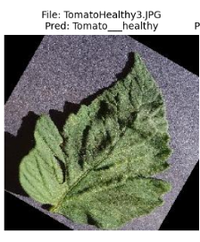
- ResNet18 Model:
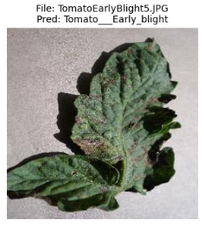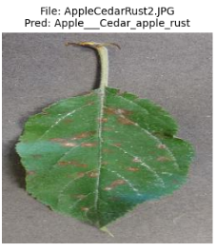
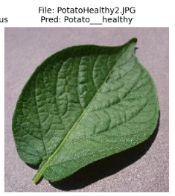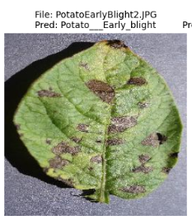
Both the models predicted the images correctly.

Phase 4: Hugging Face Generative AI Integration
After CNN model predicted the disease, it is given to an LLM to generate:
- Disease description
- Causes
- Treatment recommendations
- Prevention tips
There are many pre-trained LLM models available in Hugging Face.
Qwen2.5-3B-Instruct model is taken for this project as it is completely open-access on Hugging Face and does not require any permission.

Phase 5: Deployment Layer
A streamlit web application is developed for real time plant disease detection and treatment recommendation.
Application workflow:
- Upload Plant Leaf Image
- Model Predicts Disease
- Displays Confidence Score
- Sends Disease Name to Hugging Face LLM
- Generates Treatment Recommendation
- Displays Result

Example Prediction: Here I am giving an example prediction given by the app.
Uploaded image:
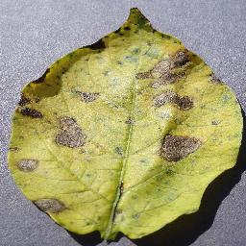
Result:
ResNet18 Identification: Potato — Early blight (100.00% Confidence)

Certainly! Here's a structured treatment plan tailored for your request.

1. Summary of the Disease (What causes it?)
Early blight in potatoes is caused by the fungus Alternaria solani. This disease starts as small, circular spots on the leaves and can spread to affect stems and tubers if left untreated. It thrives in moist conditions, especially during rainy or foggy weather.

2. Immediate Action Steps (What should the farmer do today?)
- Water Management: Reduce watering frequency and avoid overhead irrigation. Ensure that plants are watered at ground level to minimize leaf wetness.
- Pruning: Remove affected leaves to reduce disease spread within the plant canopy.
- Sanitation: Clean up and remove all infected crop residues from the field.

3. Chemical/Organic Treatments (Fungicides, ratios, and safety protocols)
For chemical treatment:
- Use a copper-based fungicide like Bordeaux mixture or copper oxychloride at a rate of 250 mL per hectare.
- Apply this fungicide every 7 to 14 days until the disease is under control.
For organic treatments:
- Alternatively, you can use an organic option such as lime-sulfur at half strength (250 g of sulfur powder and 5 L of water). Apply once weekly for two weeks.
Safety Protocols:
- Always wear protective clothing, gloves, and goggles when applying any fungicide.
- Ensure good ventilation during application to avoid inhalation of the chemical spray.
- Keep children and pets away from treated areas until it is dry.

4. Future Prevention (How to keep the soil and next harvest clean)
- Soil Management: Rotate potatoes with non-host crops like corn, beans, or squash for at least two years before returning to potato cultivation.
- Healthy Soil: Maintain a healthy level of organic matter in your soil through composting and green manure practices. Healthy soils are less prone to disease outbreaks.
By following these steps, the farmer can effectively manage early blight on their potato crops and prevent future occurrences.

